Michael Stroud, Emily Kloeppel and Joshua Freeman

IMSE 4310

5/9/2022

Dr. Noble

Case Study on Panchero’s, Columbia, Missouri

**Introduction/ Problem Description**

The main problem in the Panchero’s production system is the amount of time it   
takes to complete an order. There are lots of varied factors that go into the amount of time including the number of workers, the complexity of the customer’s order, the skill of the worker and inventory on hand. Additionally, a major factor in this problem is the customer. If it is the first time a customer has been to the place, they do not know what is on the menu and what the options in the food line are. There can also be other difficulties such as machine errors, tears in tortillas, no extra food product ready, etc. The goal of this project is to determine how many workers are necessary to obtain an optimal time, and how many stations are needed to maximize the profitability of the location.

We observed the times to get through an order at the Panchero’s off Stadium Blvd. We recorded data for the lunch rush, from 12pm-1pm and dinner rush, from 5pm-6pm. While observing the lunch rush, we noticed that the customers would typically come in waves rather than a constant flow of entrance. During the lunch rush, Panchero’s only had 3 workers, a tortilla maker, a filling station worker, and a cashier. However, during the dinner rush, they had 4 workers with two employees at the filling station. In each rush, the employees were organized in a Push fashion. Each worker performed the duty at their station and passed the product down the line. Throughout this observation, we did a time study to determine the bottleneck station and the times for each station. After this time study, we determined that the bottleneck was the filling station. This was interesting to us because we assumed the bottleneck would be the tortilla station due to the time it takes to press and cook the tortilla.

The fishbone diagram includes all the distinct factors that can contribute to the problem. These include the categories of workers, environment, inventory, machines, customers, and management. Amongst these categories are subsections such as ingredient quality, employee ability, customer requests, scheduling, etc.

After the time study and creating the fishbone diagram, we modeled a simulation, conducted lean analysis and line balancing. Once these results were computed, we were able to analyze the data and determine recommendations for Panchero’s.

**Analysis / Results / Discussion**

**Lean Analysis**

Lean is the active endeavor of removing the eight types of waste or Muda. The eight types of waste are the following: Defects, Overproduction, Waiting, Non-Utilized Talent, Transportation, Inventory, Motion, Extra-Processing. Definitions of the eight types of waste can be found in Figure 1.1.

The first waste to address is defects. Six Sigma focuses on improving process output quality by identifying and removing the causes of defects. While collecting data observations were made of the following defects. We observed a dropped plate, and the employee didn’t get a new one. This is undoubtedly a health hazard and further training needs to be put into place. We observed unclean table in the lobby. No employee was going around trying to clean the tables after a customer left. A torn burrito was also observed and is considered a defect. However, the employee offered to fix problem by double wrapping the burrito in another tortilla. Double wrapping fixes the defect and gives customer a reward. The torn burrito defect was caught and managed in exceptional fashion. Of the eight wastes defects were the most common and steps need to be taken to ameliorate the causes of the defects.

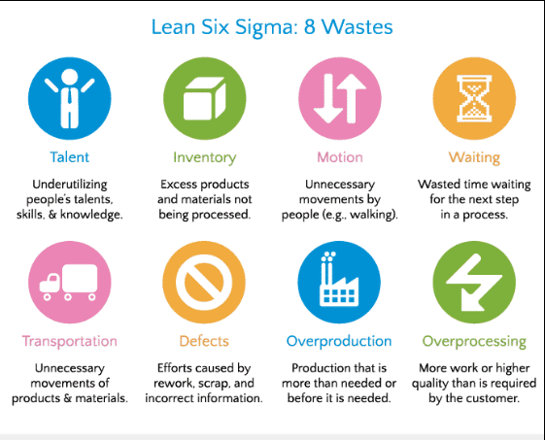

**Figure 1.1**

Types of waste

Several other types of wastes were not observed. Overproduction, Waiting, Transportation, Inventory and Motion wastes could not be found in our limited period of data collection. Non-Utilized Talent could not be determined as our team did not get the chance to build interpersonal relations and recognize skill, talents, and knowledge of the employees.

The last type of waste to be considered is Extra-Processing. One of the steps within the Panchero’s assembly line is bobbing. Bobbing is the process of using a bob or spoon to mix the contents of the burrito. While it is tempting to say that bobbing is an Extra-Process our team has concluded that this is not the case. Bobbing is a major selling point. Bobbing décor can be seen along the walls and adds to the brand's theme. Bobbing separates Panchero’s from their competitors. In the end Bobbing is not considered Extra-Processing because of its relation to the brand image.

**Six S Audit**

Lean analysis also often includes a Six S audit. Six S was performed during the lunch rush. The results can be seen in Figure 2.4. The sum of the audit yielded a score of 88. It is important to note that some of the scores could not be accurately measured. The evaluation of documents storage and documents control could not be identified from inspection. This is because the back room could not be seen from the lobby. The lack of information on important areas such as the dishwasher, kitchen, and office discredits the accuracy of our Six S audit substantially. More information about these areas would be immensely helpful in determining a more accurate score. Because documents storage and documents control could not be identified a stand in value of 4 was used.

**IE Technique: Line balancing**

Industrial engineering techniques turn our data collection into solutions. In this case study the objective is to produce solutions that solve high time in queue. To accomplish this goal two IE techniques were implemented. Line Balancing was performed to identify the lower bound of number of workers and Smoothness Index was calculated to find the impact of the bottleneck on system performance.

The results of the line balance yielded for the unexpected results. In the Lunch period of lower demand, the lower bound of number of workers is 2. This is unexpected because while collecting data our team felt the workers were constantly busy. One reason for this perceived contradiction may be the variance of customers per hour. During the lunch rush, customers appeared to be arriving in waves as each of the surrounding companies let their employees out on lunch break. Line balancing assumes wait time is a non-issue as it does not consider variance in arrival rate. Due to the high variance, we agree with the company in implementing a capacity buffer in the form of a third employee.

The Panchero’s system operated with a smoothness index of 30.85 in the lunch period. A smoothness index of zero indicates a perfect balance. A smoothness index of 30.85 can be interpreted as the bottleneck has a high impact of system performance. From our time study it was determined the filling worker was by far the bottleneck.

In the Dinner period of higher demand, the lower bound of number of workers is 4. During the dinner rush the variance of arrival rate was far smaller. Customers appeared to be flowing consistency into the store. The workers appeared busy but not overworked.

The Panchero’s system operated with a smoothness index of 10.93 during the dinner rush. The addition of the secondary filling worker increased the capacity of the filling server. Two burritos could be filled at the same time. From our time study it was determined the tortilla worker was the bottleneck by a fraction. The bottleneck placed at the beginning of the line paces the other servers and created a far smoother system.

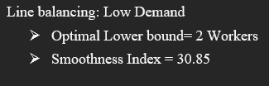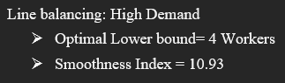

**Value Stream Map**

Making a value stream map is a good tool that breaks down a large corporate problem and makes it into smaller subsections and their relationships. In our simplified example we will start the analysis at the top left corner of Figure 1.2. We have our supplier which would act as shipping company for food and other necessities like food containers. We assumed a three-day delivery time from the time the order is placed to when it arrives at the store front. From obtaining this shipment the business can stock its food stations. Now our restaurant is ready to receive orders from the customers. On a rough average between both lunch and dinner rush we assumed it took customers 30 seconds to place an order to the tortilla worker. From there, it takes 2 minutes to cook the tortilla before it is ready to be moved to the Filling Worker. When the tortilla is ready, it almost instantaneously transfers to the Filling Worker, we assumed 3 seconds to account for grabbing the serving utensil. Then, the Filling Worker will meet all the requirements of the customer, taking an estimate of one minute before it then moves to the Cashier. Before the order is met at the register, the burrito is wrapped, which is why we assumed ten seconds of lead time. The Cashier moved quickly, and had you checked out in about thirty seconds. Finally, before the customer exited the system, they would have to grab their drink cup and food order, this took approximately five seconds. In total our system had 38 seconds of lead time and 210 seconds of processing time. That gave Panchero’s a remarkable value added/non-value added ratio of 5.53. This means we are processing about 5.5 times longer than we are transitioning, which is very efficient assuming the processing times cannot be shortened.

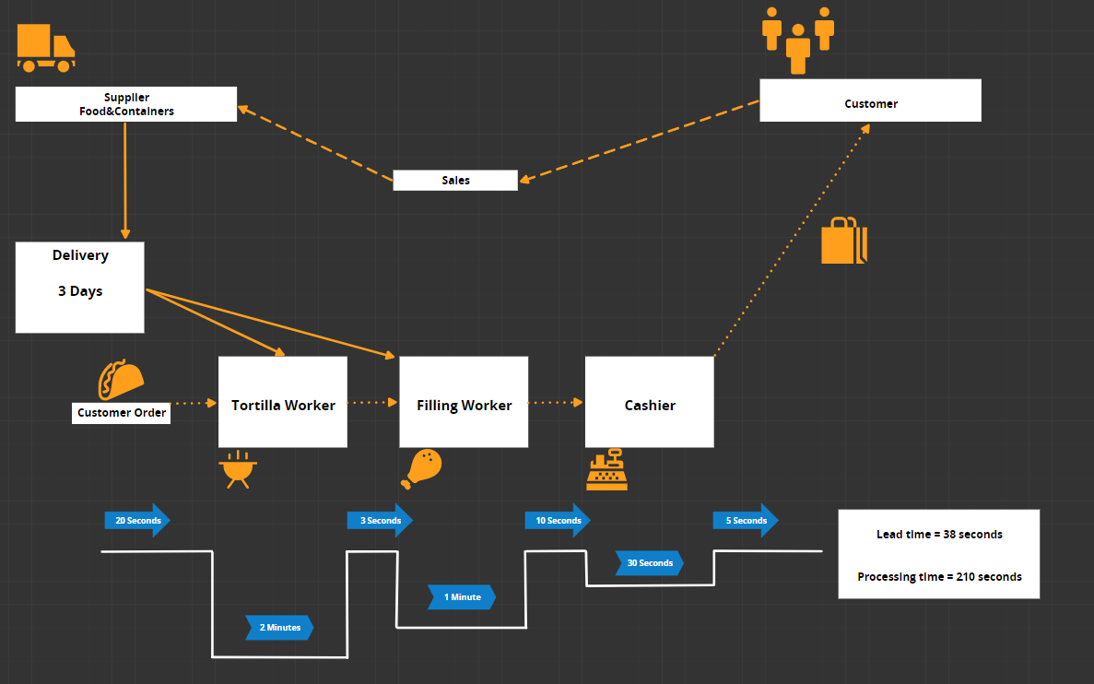

**Figure 1.2**

Value Stream Map

**Fishbone Diagram**

To define the fishbone diagram, emphasis was placed on overall workable between customer to employee to workstations. Defining the characteristics and systematically breaking down the system at hand is critical for analysis. In doing this, knowledge of the flow can be seen, and improvements can start to be drawn and tested. For our diagram, we divided it into six different areas Customers, Management, Machines, Environment, Workers, and Inventory.

This covers the most frequented problem areas in food chains.

Looking into the customers' header, we found issues in customers' ordering and payment methods that would overall hold up the line. Customers deciding what to order was the main cause of line holdup during the lunch rush, as they would enter with little to no queue and the workers were waiting on them so the workers could begin preparing the food. Another issue was with the payment method. Panchero’s has a reward system and if a customer wants to earn points, they can either scan the receipt or barcode via their app. If the customer chooses to scan the barcode, getting out their phone and navigating to the app could potentially lead to a large increase of time in system.

Machines are an obvious causation of wasted time, as many problems can come about without warning. If the grill were to breakdown, Panchero’s ability to create tortillas for burritos would be put at a standstill and limit customers to bowls. This could lead to a loss in throughput as customers might leave if they cannot get their desired food item. Similarly, the failure of the card reader could lead to an even worse loss of customers. Most customers tend to pay with a card nowadays, if customers only have the option of cash, they might leave the system.

Workers are the fuel of the system and have a direct tie to production. An issue that can occur is multitasking in the way where a worker follows a singular order all the way through the line. If a clump of customers came in at once, that would leave a large queue of people waiting to be served. The skill of the employee also plays a role, as a more experienced worker would spend less time looking for the relevant item to fill the order. Having a well-trained staff would prove to be beneficial.

Management has a specific role in maintaining the flow of the system. Whether that is through scheduling of the shifts or supervising the employees, the importance cannot be stressed enough. Scheduling more workers for the busier hours to keep a constant flow of completed orders helps the customers get in and out quicker. Overall, this creates a good image for your business, being able to serve a majority of orders correctly and quickly.

Environment affects the efficiency of the staff and how well they can work. Issues like the temperature of the room, if it's too hot might lead them to need more breaks as fatigue sets in quicker. Then things as simple as the compatibility of the staff affect how good of a job they do. If a worker enjoys their co-workers and has a suitable environment, their mood would be kept at a happy level, leaving them to enjoy the work and time in the facility. A happy staff will be seen as a customer and leave them with a good impression.

Inventory is the last headline our model covered. Maintaining the proper level of food and utensil level is crucial for success. Keeping just enough perishable items on hand is ideal, as too many and food spoils, too little and you can’t fulfil customer orders. This is a hard issue to solve but can lead to a lot of lost revenue when done improperly. As for the non-perishable items like utensils and take out containers, keeping a similar level of just enough is important. Too much and workers struggle to work in a cluttered environment but too little and customers' ability to get or eat their food is hindered. Taking inventory levels into consideration will ultimately benefit not only the customer but the workers as well.

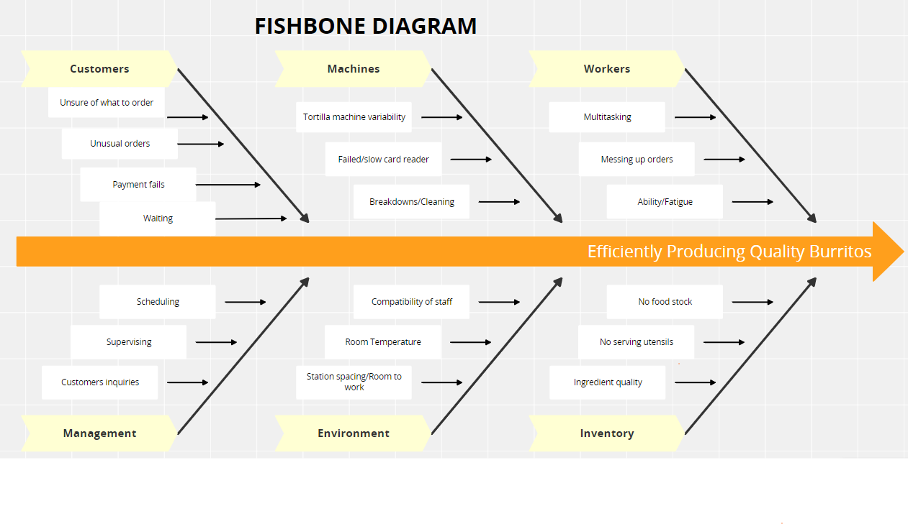

**Figure 1.3**

Panchero’s Fishbone Diagram

**Simio Model**

Our approach for the Simio was to simplify operations and construct our model from the working stations. In our analysis of the business, we noted how they would have workers posted up in three different areas the tortilla station, filling station and the cashier. For this reason, we created a server for each of the mentioned workers. Furthermore, we utilized the triangular distribution in all our servers as we did not have a bunch of data to go from. With this distribution it takes in three straight forward values. The first is the minimum processing time, then the second is the mean times for all the data, finally the maximum value is input. Then we used connectors to create a path between the servers as there was a negligent amount of time in between operations. Finally, for our Entrance we selected the uniform distribution with a mean value of 60/# of customers per hour (# of customers was dependent on time of day). In conclusion a completed order was noted as the number of observations that went into the exit station.

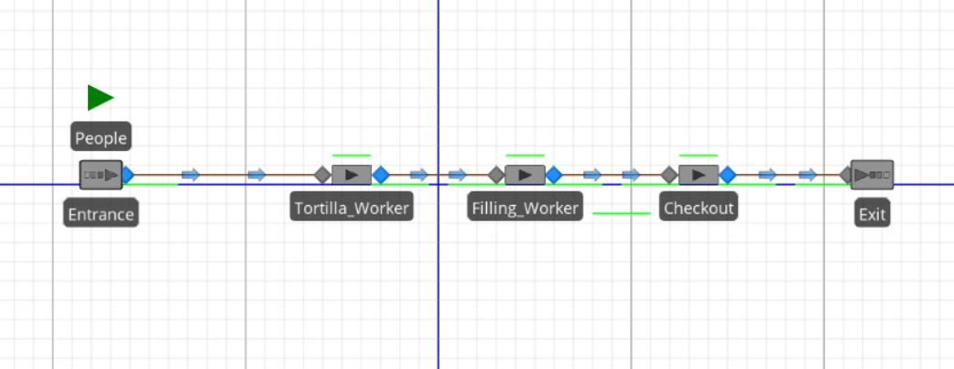

**Figure 2.1**

Simio set-up

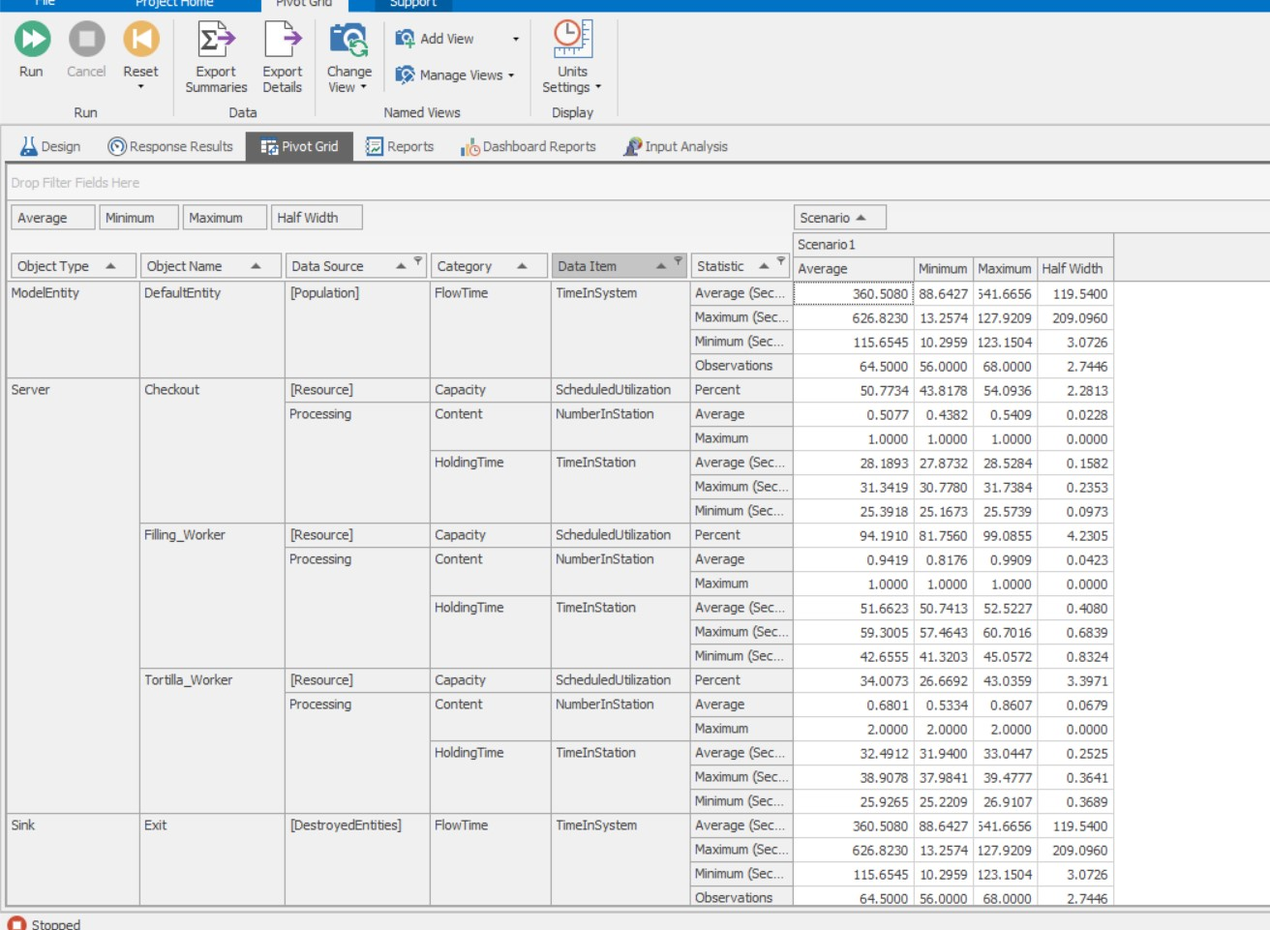

**Figure 2.2**

Simio results for Dinner rush

**Results: Dinner**

65 Customers entered

65 Customers exited with order

Checkout Utilization = 50.77%

Filling_Worker Utilization = 94.19%

Tortilla _Worker Utilization = 34.01%

**Interpretation: Dinner**

Our highest utilization value was held by the filling worker station, making it the bottle neck of the operation. While our Simio did not include balking, as we did not observe any during our data collection, aiding this operation would help us to take in more people's orders. In order to help this operation, we suggest adding another filling worker during this time of the dinner rush.

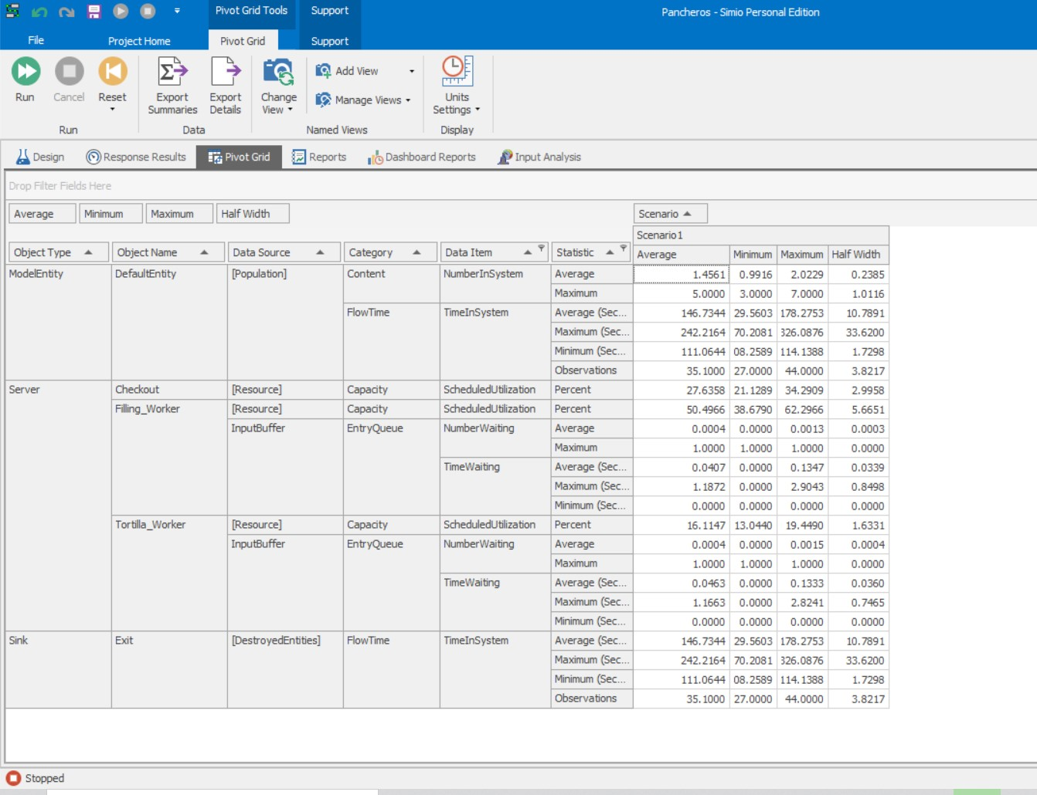

**Figure 2.3**

Simio results for Lunch rush

**Results: Lunch**

36 Customers entered

36 Customers exited with order

Checkout Utilization = 27.64%

Filling_Worker Utilization = 50.50%

Tortilla _Worker Utilization = 16.11%

**Interpretation: Lunch**

Similar to that of the dinner rush, the lunch rushes bottleneck was at the filling station. However, the filling station is only at 50% utilization, meaning they still have plenty of time to spare and there is no need for a second worker during this time period. This means as a company we can save money by not paying an extra worker for this time period.

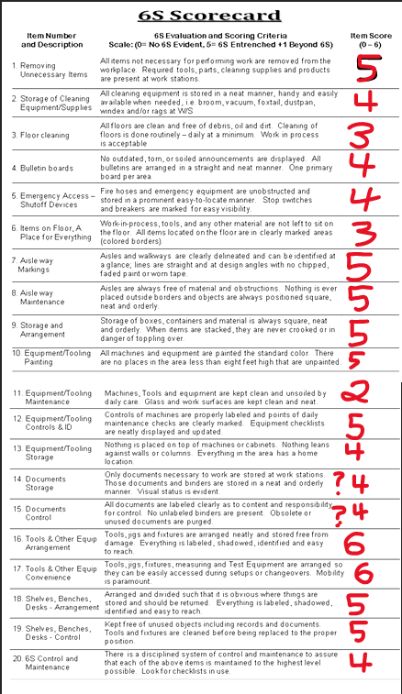

**Figure 2.4**

6S Scorecard

**Recommendations/Conclusion**

After looking at the results and analysis, we determined that our top priority recommendation would be to add another worker for the lunch rush. This worker would help the filling station when needed, otherwise they would be assigned to cleaning tables, restocking, etc. During the lunch rush, specifically, we noticed that the tables would get messy quickly, and customers were cleaning their table before they sat down. Additionally, the utensils station was starting to run low by the end of the rush. This additional employee would help smooth out the line balancing by assisting the filling station as well as acting as a capacity buffer to help the variance in arrival rate.

Another recommendation would be to add an additional stovetop/grill for the tortilla worker. Additional workers can always be staffed during periods of high demand. More workers could be placed in the fillings category until fillings was by far the quickest server. However, the facilities capacity is limited by the number of cash registrars and stovetop space. Although the tortilla station may not be a bottleneck every day, during periods of increased demand it will become the limiting factor. By adding another stovetop, the tortilla worker can have multiple tortillas cooking at a time in anticipation of people ordering burritos, tacos, and quesadillas. Additionally, another stovetop allows for more space to cook the quesadillas and meats/veggies for the filling station line. This can reduce the time in system as customers may not be in the system as long if their tortilla is already made. Furthermore, cooking more meats and vegetables can prevent a shortage during the rushes. By avoiding this, customers will not have to wait for their desired meat or vegetable to finish cooking.

After the time study and simulation, we did a cost analysis on the profit for Panchero’s. We assumed that one customer was equal to one burrito, and there is a profit of 2 dollars per burrito. The calculations are shown in Figure 3.1. These calculations were performed for both the lunch rush and the dinner rush.

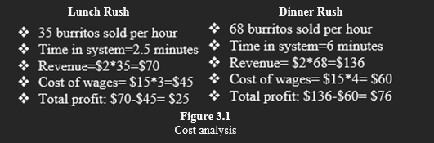

The lunch rush demand rate was 35 burritos per hour. At a profit of 2 dollars per burritos the Panchero’s revenue is $70 dollars. However, the company employed three workers at a rate of $15 dollars an hour. Subtracting out the cost of employment it is found that the profit rate is $25 dollars during lunch rush level demand. Contrasting this with the dinner rush it is seen that a demand rate of 68 burritos and employing 4 workers leads to a profit rate of $76 per hour during dinner rush level demand.

Based on recommendations, the profit of Panchero’s could increase due to the reduced time in system. With the lower time in system, the wait line will move faster, and customers are less likely to balk to go to another food place, such as chipotle. Additionally, adding another employee during the lunch rush that can aid in cleaning and restocking will improve the chances of customers coming back. By not losing customers and not receiving bad reviews, Panchero’s will have an increased number of new customers as well. Our recommendations can help Panchero’s gain more profit by decreasing the number of lost customers and increasing the number of new customers. This increase in customers can aid in the hiring of more workers and cover the cost of an additional worker during the lunch rush. In conclusion, Panchero’s has an efficient process, but there is always room for continuous improvement.

Sources:

[Simplifying Lean Six Sigma | Making Lean Six Sigma Approachable (wordpress.com)](https://leansixsigmasimplified.wordpress.com/)

**IMSE 4310 - Team Design Project (Sp22)**

**Team Members: _____Michael Stroud, Emily Kloeppel and Joshua Freeman __________**

|  |  |  |
| --- | --- | --- |
| FACTORS | CREDIT | COMMENTS |
| **Problem Description (10%)**  - scope  - key performance measures  - observations |  |  |
| **Analysis / Results / Discussion (50%)**  - Lean Analysis (15%)  - Fishbone Diagram (5%)  - Simio simulation (15%)  - IE Technique (line balance, kanban /CONWIP, layout, MH, cells) (15%) |  |  |
| **Recommendations / Summary (15%)**  -prioritized recommendations  - include performance / cost analysis |  |  |
| **Format / Writing Mechanics (5%)**  - logical flow  - well illustrated  - well written |  |  |
| **Progress Report (10%)**  - submitted 4/17/18 | 9.5 |  |
| **Oral Presentation (10%)**  - 3 minutes MAX - 5/3/18 | 10 |  |

Grade _______________/100